Exploratory Data Analysis (EDA) Report

1. Statistical Analysis

Summary Statistics
Split | Text Type | Average Word Length | Average Sentence Length | Type-Token Ratio
by_polishing | AI | 3.16 | 92.25 | 0.71
by_polishing | Human | 3.17 | 97.56 | 0.72
from_title | AI | 3.15 | 77.68 | 0.70
from_title | Human | 3.17 | 97.45 | 0.72
from_title_and_content | AI | 3.15 | 90.24 | 0.67

Global Averages
Text Type | Average Word Length | Average Sentence Length | Type-Token Ratio
AI | 3.16 | 86.72 | 0.69
Human | 3.17 | 97.51 | 0.72

Average Word Length Bar Chart
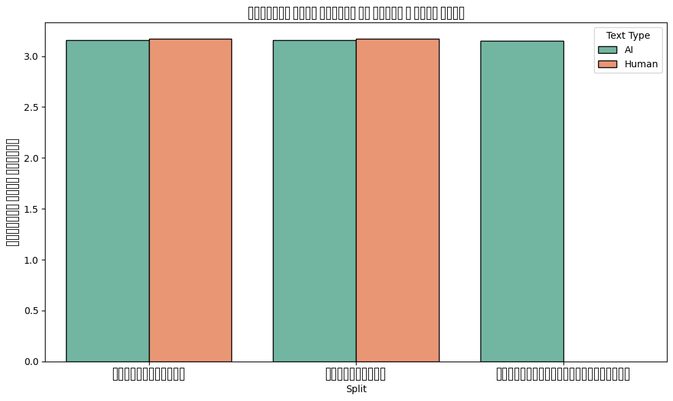

Type-Token Ratio Bar Chart
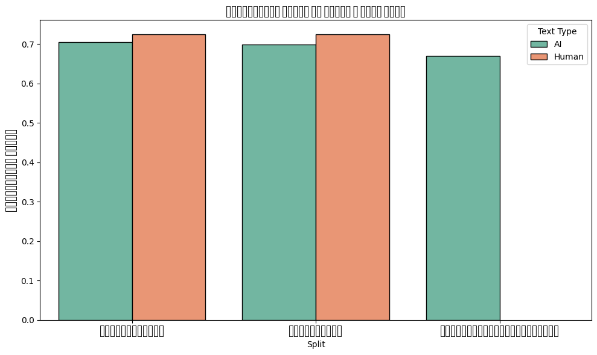

2. Lexical Analysis

Lexical Means
Split | Text Type | function_words_count | punctuation_count | ان_count | جمع_count | بحث_count | الي_count | درس_count | علي_count
by_polishing | AI | 4.96 | 11.87 | 16602 | 9600 | 11907 | 23908 | 18700 | 29407
by_polishing | Human | 5.69 | 12.75 | 7448 | 2480 | 1979 | 5556 | 3514 | 6403
from_title | AI | 4.11 | 8.43 | 18582 | 11031 | 17973 | 25618 | 28692 | 27464
from_title | Human | 5.67 | 12.78 | 7740 | 2575 | 2078 | 5777 | 3619 | 6641
from_title_and_content | AI | 4.90 | 11.88 | 24452 | 10918 | 24562 | 26462 | 20177 | 33528

Keyword Sums
Text Type | ان_count | جمع_count | بحث_count | الي_count | درس_count | علي_count
AI | 59636 | 31549 | 54442 | 75988 | 67569 | 90399
Human | 15188 | 5055 | 4057 | 11333 | 7133 | 13044

